Q1. What is a Common Table Expression (CTE), and how does it improve SQL query readability?
- A CTE (Common Table Expression) is a temporary result set defined using the WITH clause that exists only for the duration of a query.
Why it improves readability
- Breaks complex queries into logical steps
- Easier to debug and maintain
- Can be reused multiple times in the same query
- Cleaner than deeply nested subqueries
Q2. Why are some views updatable while others are read-only? Explain with an example.
A view is updatable only when SQL can clearly map changes back to a single base table.
Updatable View (Simple)
CREATE VIEW simple_view AS
SELECT name, score
FROM Student_Performance;
Read-Only View (Complex)
CREATE VIEW complex view AS
SELECT course, AVG(score)
FROM Student Performance
GROUP BY course;
Why not updatable?
- Uses GROUP BY, AVG() → aggregated data
- No direct row mapping back to original table
Rule of thumb
A view is NOT updatable if it contains:
- GROUP BY, DISTINCT, JOIN, AGGREGATE FUNCTIONS
Q3. What advantages do stored procedures offer compared to writing raw SQL queries repeatedly?
Stored procedures are precompiled SQL blocks stored in the database.
Benefits
- Performance → precompiled, faster execution
- Security → restrict direct table access
- Reusability → write once, use many times
- Maintainability → logic centralized in DB

Q4. What is the purpose of triggers in a database? Mention one use case where a trigger is essential.
A trigger is automatically executed when an event happens on a table
(INSERT, UPDATE, DELETE)
Purpose
- Enforce business rules
- Maintain data integrity
- Automate actions
Example Use Case (Audit Logging)
CREATE TRIGGER before_insert_student
BEFORE INSERT ON Student_Performance
FOR EACH ROW
SET NEW.city = UPPER(NEW.city);
This ensures city names are always stored in uppercase.
Real-world use case
- Automatically update last_modified timestamp
- Prevent invalid data entry
- Maintain audit logs
Q5. Explain the need for data modelling and normalization when designing a database.
Data Modelling
Designing how data is structured in tables and relationships.
Example:
- students
- courses
- enrollments
Normalization
Process of organizing data to reduce redundancy and improve integrity.

Why it’s important
Benefit | Explanation
Reduces redundancy | Avoid Duplicate data
Improves consistency | One source of truth
Better performance | Efficient queries
Prevent anomalies | No update/delete issues

Example (Before Normalization)
Student | Course | Mentor
Aarav | SQL | Mr. Iyer
Aarav | Python | Ms. Nair
After Normalization
- Students
- Courses
- Enrollments
No duplication, clean structure.

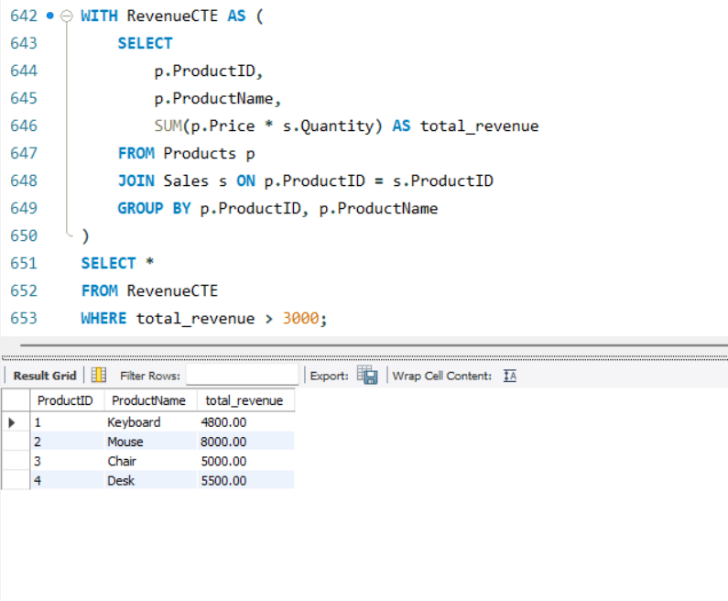
Q6. Write a CTE to calculate the total revenue for each product(Revenues = Price × Quantity), and return only products where revenue > 3000

Q7. Create a view named that shows: Category, Total Products, Average Price

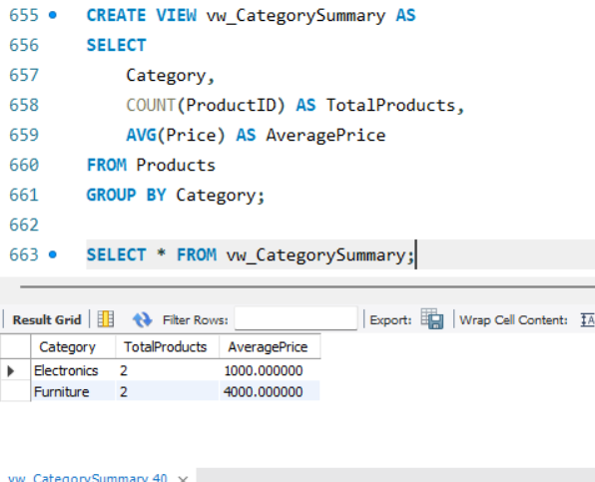

Q8. Create an updatable view containing ProductID, ProductName, and Price. Then update the price of ProductID = 1 using the view.
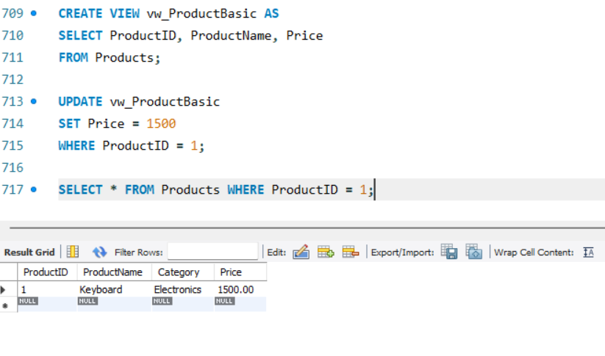

Q9. Create a stored procedure that accepts a category name and returns all products belonging to that category.

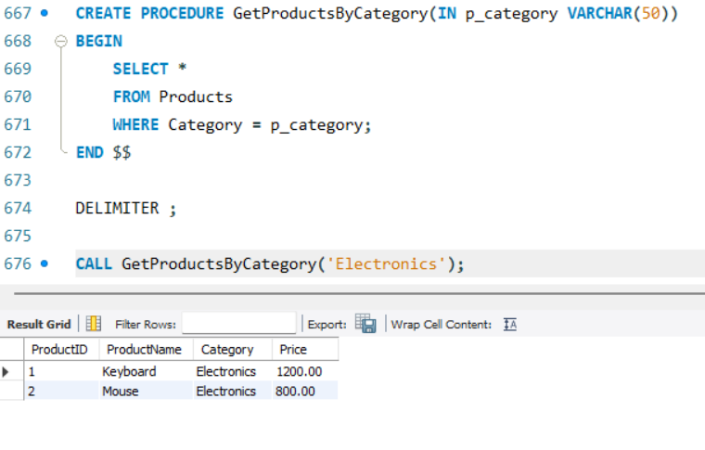

Q10. Create an AFTER DELETE trigger on the products table that archives deleted product rows into a new table Productarchive . The archive should store ProductID, ProductName, Category, Price, and DeletedAt timestamp
